ONLINE PROCEDURE TO ENROLL IN A PhD PROGRAM
Attention: before you start the online procedure, make sure that you have prepared the required documents in .pdf. You will be asked to upload them at the end of the enrollment procedure.

1. https://studentionline.unipv.it/esse3/Home.do. Select the English version and login (top right menu).

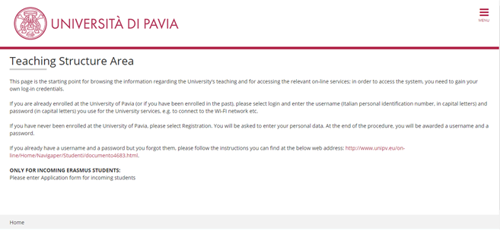

2. This is your personal homepage.

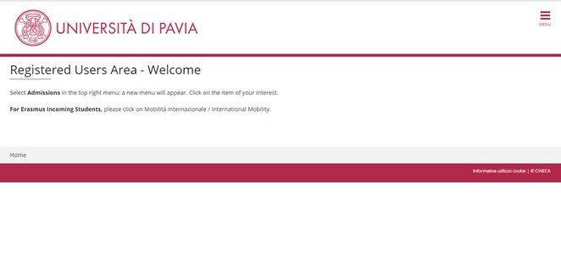

3. Click on “Admissions” on the top right menu, then “Enrollment”.

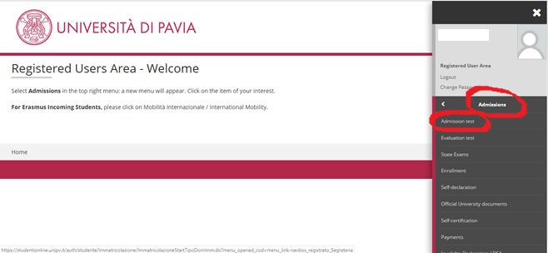

4. Click on the blue “Enrollment” button at the bottom of the page.

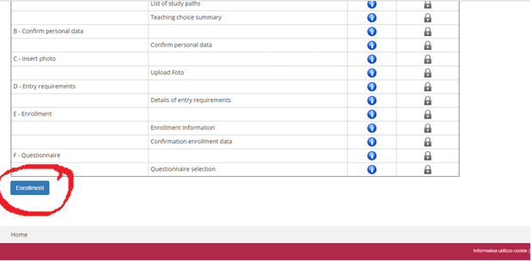

5. Select “standard enrollment”.

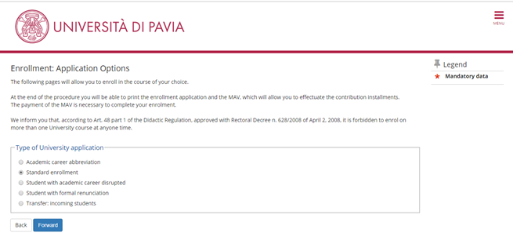

6. Select “Enrollment to courses with access programmed at national level”.

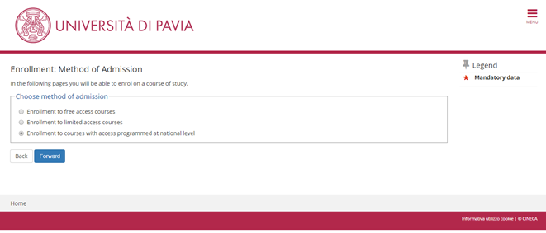

7. Select “PhD programme”.

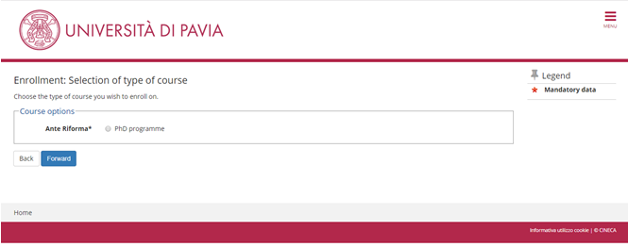

8. Select the PhD course in which you wish to enroll.

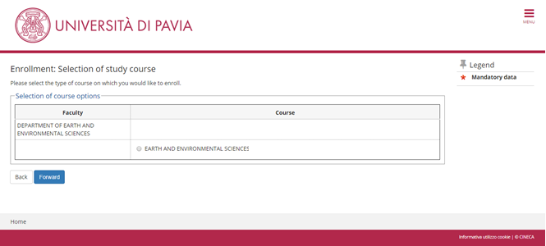

9. If the data are correct, click on “confirm”; otherwise, click on “enrollment” in the left-hand menu, cancel the enrollment procedure and start a new one.

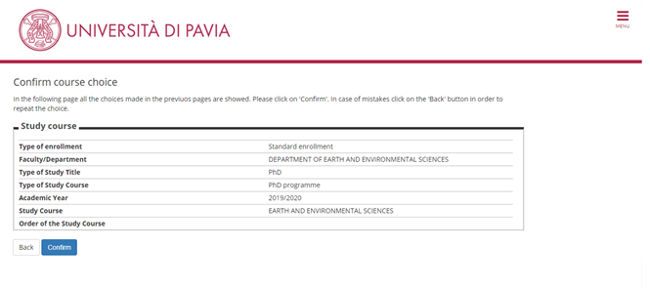

10. Upload a passport-size photo of yours.

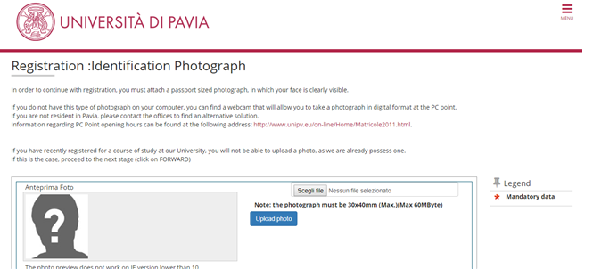

11. In the “Qualifications required” section, you should already have a green light in one of the four options. Click on the “Proceed” button at the bottom of the page.

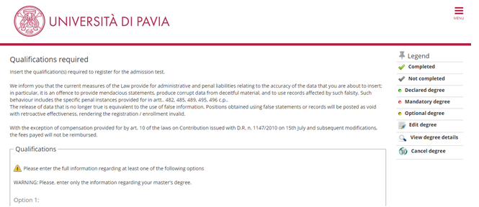

12. Don’t fill the blank fields. If you have a disability, select “yes” in the relevant field.

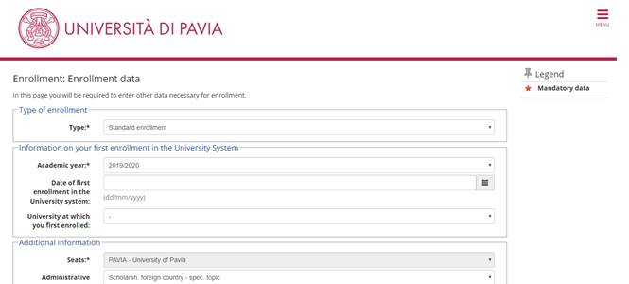

13. Check the data and click on the “confirm” button at the bottom of the page.

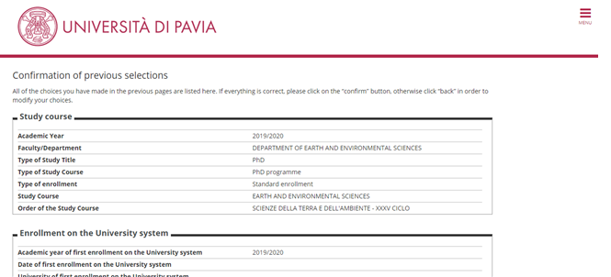
14. In order to upload the documents required, click on “attach file” (see the APPENDIX at page 18 for the list of documents you are supposed to upload).

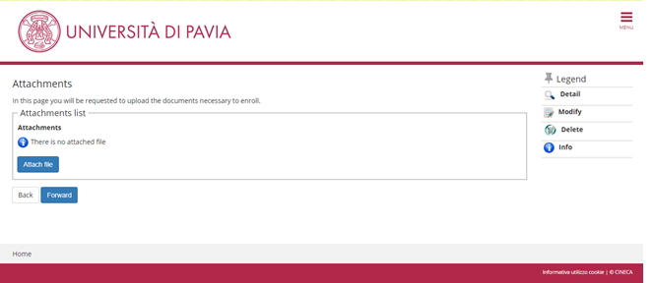

15. Upload the documents required…

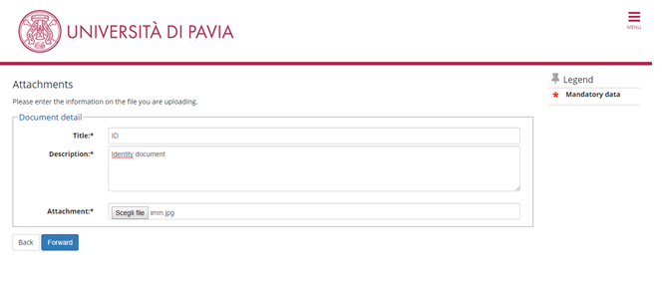

16. ... then click on the “forward” button.

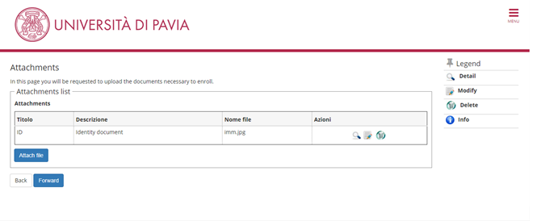

17. The procedure is complete. There is no need to print or save the enrollment application.

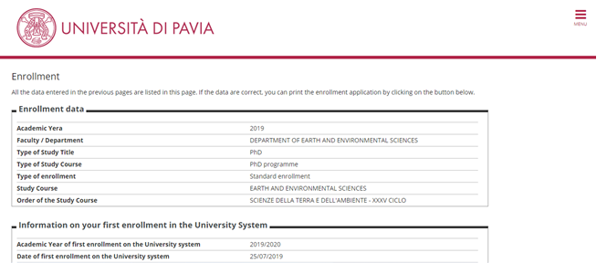
APPENDIX
WHICH DOCUMENTS DO I HAVE TO UPLOAD?

- PAYMENT RECEIPT OF THE ENROLLMENT FEE (€ 156,00)
The participation fee must be paid via the PagoPA system, with one of the following methods:
  - direct payment (credit cards or bank transfers through the affiliated banks) in the “Payments” section of your Personal Area, by clicking on the invoice number, then on the “Pay by PagoPA” button;
  - deferred payment, bringing your PagoPA invoice to a bank, a post office, a SISAL or Lottomatica point, or using your home banking system. Candidates can print the invoice in their Reserved Area, by clicking on the invoice number and then on the button “Print notice for PagoPA”.
Please note that the enrollment won’t be finalized until the payment of the enrollment fee.
- COPY OF A VALID IDENTITY DOCUMENT
- COPY OF YOUR ITALIAN FISCAL CODE CARD/DOCUMENT, if you already have it; otherwise, please send a copy of it to fabio.panza@unipv.it as soon as you’ll get it.
- ENROLLMENT DECLARATION (see page 19-20)
- ONLY FOR WOMEN: DECLARATION ON PREGNANCY (see page 21)
- ONLY FOR SCHOLARSHIP GRANTEES: in this case, please contact fabio.panza@unipv.it who will assist you in preparing the specific documents required for the scholarship grantees.

 | UNIVERSITÀ DEGLI STUDI DI PAVIA  SERVIZIO RICERCA E TERZA MISSIONE  Polo Cravino - Via Ferrata, 5 – 27100 Pavia  Tel. 0382 985021/37/84/82

To the Rector of the University of Pavia

The undersigned _______, born in ______ on __________, who has obtained a PhD position with scholarship/without scholarship for the PhD programme in __________________________ - XXXVII cycle
HEREBY DECLARES, UNDER HIS/HER OWN RESPONSIBILITY

pursuant to the DPR (Italian law) n. 445 of December 28, 2000 (“Testo Unico delle disposizioni legislative e regolamentari in materia di documentazione amministrativa”), art. 46 and 47

- not to be simultaneously enrolled, and to commit him/herself not to enrolling for the whole duration of the PhD course, in any University course whatsoever, in Italy or abroad, except in case of jointly supervised agreements (cotutelle) and in case of medical specialization;
- to commit him/herself to performing properly his/her research activity, maintaining the confidentiality of any information he/she may happen to know during the research activity;
- not to be involved in a work activity and to commit him/herself to asking for the Teachers Board approval should he/she intend to start an external, occasional and limited work activity;
- to perform the following external and occasional work activity: _________________ and to commit him/herself to asking for the Teachers Board authorization to continue working;
- to be an employee of the following company ____________________ which has subscribed an agreement with the University of Pavia;
- to be a civil servant in the following Italian public administration: _______________________
- and to have applied for a study leave for the period of the PhD programme;
 to commit him/herself to attending the PhD programme as a full-time activity;
 to be aware that the University administration does not have any responsibility for missed communications due to wrong information concerning permanent address or contacts, or due to belated or missing notice about variation of the above-mentioned addresses, nor of any postal or telegraphic errors due to third party or to unforeseen and fortuitous events;
 to communicate immediately any change of residence or contact information occurring after the presentation of the application form;
 to be aware of the penal sanction in case of false statement, in accordance with art. 76 of the DPR (Italian law) n. 445 of December 28th, 2000;
 to be aware of art. 75 of DPR (Italian law) n. 445 of December 28th, 2000 about the loss of benefits related to the assignment if, after a check, the Administration discovers the untruthfulness of the aforesaid declarations;
 to allow the University of Pavia – Research Division to use collected personal data for the institutional purposes, in accordance with the D. LGS (Italian Law) n. 196 of June 30th, 2003 (“Legislation concerning the protection of personal data”), and to allow the University to communicate such data to the University administrative structures and to the entities directly involved in the PhD student’s juridical and economic position.
Date |  |  |  |  |  |  |  |  |  |  |  |  |  |  |  | Signature

UNIVERSITÀ DEGLI STUDI DI PAVIA

SERVIZIO RICERCA E TERZA MISSIONE

Polo Cravino - Via Ferrata, 1 – 27100 Pavia
Tel. 0382 985021/37/84/82

In order to allow the University Administration to comply with the Italian regulations on maternity protection, and considering the provisions provided by D. I. (Italian law) of July 12, 2007, the undersigned _________________________________ , born in _____________________ on ___________ , PhD student in ____________________ - XXXVII cycle
COMMITS HERSELF
in case of pregnancy, to informing immediately the PhD office and submitting the doctor certificate stating the expected birth date, thus releasing the University from all liability in respect to any omissions.
Pavia, ____________________
SIGNATURE

